ESP32-S Wi-Fi+BT SoC Module

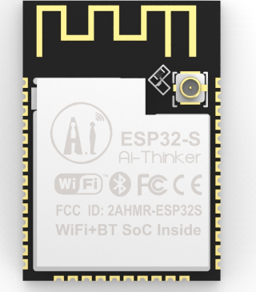
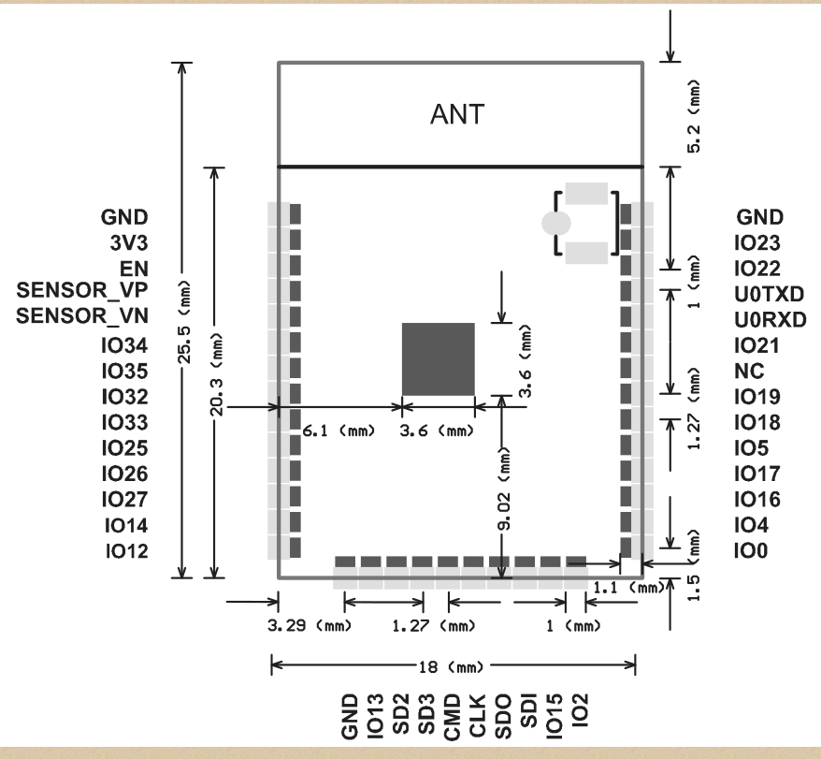

Overview
Features

Esp32-S has a highly competitive package size and ultra-low power technology.
Esp32-S can be widely used in various of networking, for home automation, industrial wireless control, baby monitors, wearable electronics products, wireless position sensing devices, wireless positioning system signals and other networking applications.
Esp32-S is packaged in SMD,through the standard SMT equipment to achieve rapid production of products,to provide customers with
High reliability of the connection,especially for
Automation, large-scale, low-cost modern production methods,It’s suitable for all kinds of Internet of things hardware terminal occasions.

- The smallest 802.11b/g/n Wi-Fi BT SoC Module
- Low power 32-bit CPU,can also serve the application processor
- Up to 160MHz clock speed，Summary computing power up to 600 DMIPS
- Overview built-in 520KB SRAM
- Supports UART/SPI/I2C/PWM/ADC/DAC
- SMD-38 package for easy welding
- Support for OpenOCD debugging interface
- Deep sleep current as low as 6.5μA
- Embedded Lwip and FreeRTOS
- Supports STA/AP/STA+AP operation mode
- Support Smart Config/AirKiss technology
- General AT commands can be used quickly
- Support for serial port local and remote firmware upgrades (FOTA)

Product Specifications
Shenzhen Ai-Thinker Technology Co., Ltd
Address: 7/F, Fengze Building B, Huafeng Industrial Park 2th, Hangkong street,Xixiang Raod, Baoan, Shenzhen China
Website:www.ai-thinker.com Tel：0755-29162996 E-mail：support@aithinker.com
Module Model | ESP32-S
Package | SMD-38
Size | 18.0*25.8*2.8（±0.2）mm
SPI Flash | Default 32Mbit
Bluetooth | Bluetooth 4.2 BR/EDR and BLE standards
Wi-Fi | 802.11 b/g/n/
Interface | UART、SPI、SDIO、I2C、PWM、I2S、IR、ADC、DAC
On-chip Sensor | Hall sensor, Temperature sensor, Capacitive touch sensor
IO Port | 22
UART Baudrate | Support 300~4608000bps,Default 115200bps
Frequency Range | 2412 ~2484MHz
Antenna | PCB Antenna , Gain 2dBi
Transmit Power | 802.11b: 17±2 dBm (@11Mbps)  802.11g: 14±2 dBm (@54Mbps)  802.11n: 13±2 dBm (@MCS7)
Receiving Sensitivity | CCK, 1 Mbps : -90dBm  CCK, 11 Mbps: -85dBm  6 Mbps (1/2 BPSK): -88dBm  54 Mbps (3/4 64-QAM): -70dBm  MCS7 (65 Mbps, 72.2 Mbps): -67dBm
Power Dissipation | 300mA@3.3V
Security | WPA/WPA2/WPA2-Enterprise/WPS
Power Supply Range | 3.0V ~ 3.6V
Operating Temperature | -20 ℃ ~ 85 ℃
Storage Environment | -40 ℃ ~ 90 ℃ , < 90%RH
Weight | 1.5g

Contact US

